NAMING ORGANIC COMPOUNDS

Organic molecules are those that come from plants and animals. It is also called carbon chemistry as it studies the compounds of carbon except carbonates and carbon dioxide.

There is a system of naming (NOMENCLATURE) organic compounds, which was designed and recognised by international chemists. It was called the I.U.P.A.C. system.

Remember when these structures are drawn, each type of atom has a different number of covalent bonds. How many bonds will each of these elements form?

carbon hydrogen oxygen

chlorine nitrogen bromine

NAMING OF CONTINUOUS CHAIN HYDROCARBONS

|  |  |  |
| --- | --- | --- |
| Number of carbon atoms | Prefix | Alkyl group |
| 1 |  |  |
| 2 |  |  |
| 3 |  |  |
| 4 |  |  |
| 5 |  |  |
| 6 |  |  |
| 7 |  |  |
| 8 |  |  |

|  |  |  |  |  |
| --- | --- | --- | --- | --- |
| alkane | structural formula expanded | structural formula compressed | M. F. | E. F. |
| ethane |  |  |  |  |
| heptane |  |  |  |  |
| propane |  |  |  |  |
| butane |  |  |  |  |

NAMING FUNCTIONAL GROUPS USING A SUFFIX

A functional group is an atom or group of atoms attached to a parent carbon chain or ring.

|  |  |  |
| --- | --- | --- |
| Class | Functional group | Suffix |
| alkanes |  |  |
| alkenes |  |  |
| alkynes |  |  |
| alcohols |  |  |
| aldehydes |  |  |
| ketones |  |  |
| carboxylic acids |  |  |
| carboxylate ions |  |  |
| esters |  |  |
| amines |  |  |
| amides |  |  |

NAMING FUNCTIONAL GROUPS USING A PREFIX

|  |  |  |
| --- | --- | --- |
| Class | Functional group | Prefix |
| fluorine compounds |  |  |
| chlorine compounds |  |  |
| bromine compounds |  |  |
| iodine compounds |  |  |
| alkyl compounds |  |  |
| cyclic |  |  |
| amines |  |  |
| alcohols |  |  |

RULES FOR USING THE IUPAC SYSTEM OF NOMENCLATURE

1) Identify the longest continuous chain of carbon atoms.

2) Assign a number to each carbon in the longest chain, assigning the lowest number to any functional group present in the compound. If more than one functional group is present, the order of priority is

-COOH, -CHO, -RC=OR’, -OH, -NH2, double , triple

3) Define all groups within, and attached to the carbon chain.

4) Name the compound, indicating the position of functional groups within the chain and attached to the chain. If a group occurs more than once, use the prefixes: di, tri and tetra.

egs: 1) 6)

butane 3-chlorohept-1-ene

2) 7)

3-aminobutanal 3,4-diethylhexanoic acid

3) 8)

bromopropanone sodium ethanoate

4) 9)

1,2-dibromocyclohexane 7-fluoroheptan-1-ol

5) 10)

2,2-dichloro-1-pentanamine 3-methyl-2-aminohex-1-ene

ISOMERISM

Isomers are .

GEOMETRIC ISOMERS (cis/trans)

Only in straight and chain alkenes, that is, the molecule must have a carbon - carbon

bond in it.

The cis form has two similar functional groups on the side of the double bond. The trans form has two similar groups on sides of the double bond.

eg:- Draw and name the 3 isomers of dichloroethene:

Which of these have the lowest boiling point? .

Why?

Draw the geometric isomers of 2-butene

Does 1-butene have geometric isomers?

BENZENE

AROMATIC compounds are those containing a benzene ring. Benzene has a molecular formula of C6H6 and an empirical formula of . Draw the structural formulas for the following:

cyclohexene cyclohexadiene benzene

The above structure of benzene should undergo addition reactions and have bond lengths between carbons equal to single and double bonds. However this molecule was very stable and did not react as expected. Also, all 6 bond lengths were equal and had a length somewhere between a single and double bond. It was suggested and now accepted that it has an oscillating structure.

The electrons move around within the ring and are called delocalised. They do not leave the ring. Will benzene conduct electricity?

This ring with delocalised electrons means benzene reacts differently to alkanes, alkenes and cyclic hydrocarbons.

eg 1) Draw and name the 3 isomers of dichlorobenzene:

eg 2) Draw and name 5 isomers of C5H10:

Examples of compounds that are isomers of each other are:

1) aldehydes and ketones

2) esters and carboxylic acids

3) alcohols and ethers (carbon chain with an oxygen atom in the middle).

eg 1) What are the main functional groups that are isomers of C4H8O2? Name and draw 5 of them.

eg 2) What are the main functional groups that are isomers of C4H8O?

eg 3) What are the main functional groups that are isomers of C4H10O?

FACTORS AFFECTING BOILING AND MELTING POINTS

There are two factors affecting the strength of the forces between molecules from the same homologous series:

1) the number of electrons surrounding the molecule, which increases with the molecular weight

2) the surface area of the molecule

Under standard conditions, from CH4 to C4H10 alkanes are gaseous; from C5H12 to C17H36 they are liquids; and after C18H38 they are solids. As the boiling point of alkanes is primarily determined by weight, the boiling point has almost a linear relationship with the size (molecular weight) of the molecule and this rule applies to other homologous series.

A straight-chain molecule will have a boiling point higher than isomer with branched-chains due to the greater surface area in contact, thus the greater Dispersion forces, between adjacent molecules. For example, compare methylpropane and butane, which boil at -12 and 0 °C.

1-Butanol CH3-CH2-CH2-CH2-OH 118 °C

2-propanol CH3-CH(-OH)-CH3 82 °C

1-Propanol CH3-CH2-CH2-OH 97 °C

Ethanol CH3-CH2-OH 79 °C

Methanol CH3-OH 65 °C

ORGANIC REACTIONS

DIFFERENCES BETWEEN CARBON ATOMS

There are three different types of carbon atoms in the molecule below. They are:

Primary - bonded to only 1 carbon atom ( )

Secondary - bonded to 2 other carbon atoms ( )

Tertiary - bonded to 3 other carbon atoms ( ).

2-methyl-2-butanol

1. COMBUSTION

Most organic molecules will burn in oxygen to produce water and carbon dioxide. If the combustion is incomplete, then the carbon is not fully oxidised and the products are water and carbon monoxide or water and carbon (soot).

Example 1: Write the balanced equation for the complete combustion of ethane.

Example 2: Write the balanced equation for the incomplete combustion of ethane.

Example 3: Write the balanced equation for the complete combustion of ethanol.

2. SUBSTITUTION

Alkanes can have a hydrogen atom "substituted" by another atom. For example the hydrogen comes off and a halogen goes on. This reaction needs energy to break the covalent bond in the chlorine molecule and it uses light to get this energy.

light

eg: CH4 + Cl2 → CH3Cl + HCl

Example: Write the balanced equation for the reaction between ethane and chlorine gas.

The halogens react at different rates with fluorine being violent in nature and speed and substituting all available carbon - hydrogen bonds. Chlorine and bromine being intermediate in speed of reaction and only substituting one carbon - hydrogen bond and iodine not reacting under any conditions.

What property of the halogens explains this difference in reactivity?

3. ADDITION

Alkenes (and alkynes) have a molecule "added" to them to make one molecule as the product. The molecule added could be hydrogen (called hydrogenation), chlorine, bromine or water (hydration).

Example 1: Write the balanced equation for the reaction between ethyne and chlorine gas.

Example 2: Write the balanced equation for the reaction between propene and hydrogen gas.

Ni, Pd or Pt catalyst

→

Example 3: Write the balanced equation for the reaction between 1-butyne and bromine gas.

Example 4: Write the balanced equation for the reaction between 2-butene and water.

Alkenes and alkynes are said to be unsaturated. This means other atoms can be added on. Alkanes are saturated because no other atoms can be added. The carbon atoms are fully bonded to other carbon atoms with **no multiple bonds;**

( and ) between the carbon atoms.

If an "orange" bromine solution is added to an unsaturated hydrocarbon it will very quickly react to decolourise the bromine (addition reaction). With a saturated hydrocarbon the reaction will be many hours before decolourising the bromine.

**This is the test for unsaturation (alkenes AND alkynes).**

Addition of a hydrogen halide: the hydrogen halides are HCl and HBr and a special case which is not a hydrogen halide but forms similar products is HOH( ).

eg 1) propene + HCl

eg 2) 1-butene + H2O

eg 3) cis-2-hexene + H2O

4. OXIDATION

Alcohols can be oxidised to aldehydes, ketones and carboxylic acids by oxidising agents;

i) acidified potassium dichromate. What would be observed in this reaction?

ii) and acidified potassium permanganate. What would be observed in this reaction?

There are 4 types of oxidation equations

1. Oxidation of a primary alcohol to an aldehyde (mild conditions)

2. Oxidation of a secondary alcohol to a ketone

3. Oxidation of a tertiary alcohol is not possible

4. Oxidation of an aldehyde to a carboxylic acid. (strong conditions)

eg

eg

eg

5. ESTERIFICATION

Alcohols and carboxylic acids will react to form an ester and water. The most important ester is formed by ethanoic acid and ethanol reacting in the presence of concentrated sulfuric acid (catalyst) to make ethyl ethanoate.

Equation =

Esters usually have a "sweet smell" and will be used as food additives to give a nice odour like in lollies and bubble gum. Ethyl ethanoate is also used

as .

1-butanol + ethanoic acid in the presence of sulfuric acid.

REVISION

a) Write balanced equations for the following reactions.

b) What type of reaction is it?

c) Name the product organic product.

1. octane + O2

2. 1-bromopropane + Cl2

3. 1-propanol + ethanoic acid

4. 1-propanol + MnO4- + H+

5. hexanal + Cr2O72- + H+

6. 2-methylpentene + Cl2

7. 2-butanol + Cr2O72- + H+

8. octanoic acid + pentanol

9. trans-1,2-dibromoethene + H2

10. 2-methyl-2-propanol + MnO4- + H+

11. ethanol + butanoic acid

12. 2-hexene + H2O

13. cyclohexadiene + O2

14. 5-fluorohexanoic acid + heptanol

15. cyclopentene + Cl2

For the following products write a balanced equation for their preparation.

16. ethyl butanoate

17. butanoic acid

18. 2,3-dichloropentane

19. hexanal

20. 2-octanone

21. propyl heptanoate

22. 3-chloropentane

23. 2-hexanol

24. 1-bromohexane

6. POLYMERISATION

Polymers are very big molecules, containing many thousands of atoms covalently bonded to one another. If many small molecules called monomers (mono=one, mer=parts) are joined together they make a big molecule called a polymer (poly=many, mer= parts).

Synthetic polymers ( -made)

Polymers that have been synthesized (made) in a laboratory are called synthetic polymers. The reactions used to make polymers are of two main types; addition polymerisation and condensation polymerisation.

Polymerisation invloves the chemical combination of a number of SMALL, identical or similar molecules called monomers to form a complex molecule of high molecular mass. The units may be combined by:

a) ADDITION POLYMERISATION

These reactions start with an unsaturated monomer. In all these reactions the monomer has a bond that breaks. This reaction combines monomers without the elimination of atoms. The monomer is an unsaturated organic compound (CH2=CH2). The addition reaction occurs many times in the presence of a suitable catalyst to yield the polymer.

POLYETHENE

P.V.C.

POLYPROPYLENE

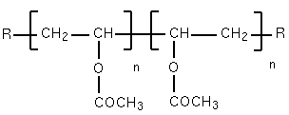

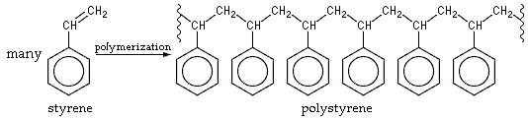

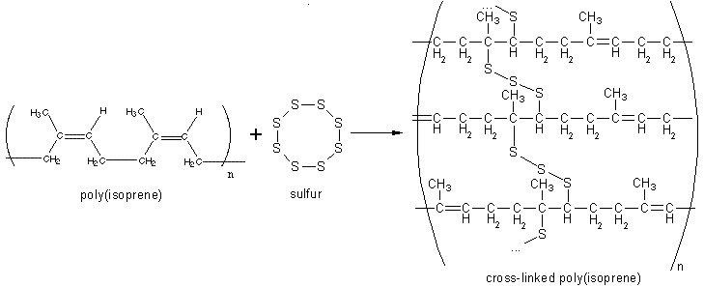

b) CONDENSATION POLYMERISATION

Condensation. Which compound is associated with this word?

In most of these reactions an -OH from one monomer reacts with -H of another monomer to make a polymer and water. In order to form long chain molecules, two or more functional groups must be present. In these reactions 2 types of monomers join together and a small molecule is removed (usually water).

NYLON (POLYAMIDE)

diamine dicarboxylic acid

TERYLENE (POLYESTER)

diol dicarboxylic acid

SILICONES

R R

| |

H-O-Si-O-H + H-O-Si-O-H →

| |

R R

Silicones have several advantages over carbon-based polymers:

1) Higher m.pt and b.pt

2) Water repellent

3) Flexible

Uses

Natural polymers

Plant and animal cells are continuously making and breaking polymers. The reaction used to make natural polymers is almost always a condensation polymerisation or an acid-base reaction.

Examples of natural polymers are carbohydrates which join many molecules together and proteins which join together . Amino acids are exactly what they say they are. They are compounds containing an amino (or amine) group, -NH2, and a carboxylic acid group, -COOH.

The biologically important amino acids have the amino group attached to the carbon atom next door to the -COOH group. They are known as 2° amino acids. They are also known as alpha-amino acids. The two simplest of these amino acids are 2-aminoethanoic acid (glycine) and 2-aminopropanoic acid (alanine).

The general formula for a 2° amino acid is:

where "R" can be quite a complicated group containing other active groups like -OH, -SH, other amine or carboxylic acid groups, and so on. It is definitely NOT necessarily a simple hydrocarbon group!

The amino acids are crystalline solids with surprisingly high melting points for a covalent molecule. It is difficult to pin the melting points down exactly because the amino acids tend to decompose before they melt. Decomposition and melting tend to be in the 200 - 300°C range. For the size of the molecules, this is very high.

The general structure of an amino acid has both a basic amine group and an acidic carboxylic acid group. There is an internal transfer of a hydrogen ion from the -COOH group to the -NH2 group to leave an ion with both a negative charge and a positive charge. This is called a zwitterion.

Draw glycine and alanine as zwitterions.

A zwitterion is a compound with no overall electrical charge, but which contains separate parts that are positively and negatively charged.

This is the form that amino acids exist in even in the solid state. Instead of the weaker hydrogen bonds and other intermolecular forces that you might have expected, you actually have much stronger ionic attractions between one ion and its neighbours.

These ionic attractions take more energy to break and so the amino acids have high melting points for the size of the molecules. Write an equation to show how alanine and glycine react. Label the peptide (amide) linkage.

7. SAPONIFICATION

Fats and oils (not crude oil) are esters of long-chained carboxylic acids and alcohols with 3 hydroxyl groups called glycerol.

The general structure of a Fat.

Saponification is the soap making process in which an oil or fat is treated with caustic

( ) solution. Hydrolysis of fats by boiling with NaOH, makes soap. Soaps are the sodium or potassium salts of fatty acids.

Saponification Reaction

Detergents are the salts of alkylbenzene sulfonates. Draw a detergent below.

Soaps and detergents function as cleaning agents because of the charged end of the ion, which dissolves in water, while the non-polar hydrocarbon end dissolves the non-polar grease, oil or dirt.

eg

***Chemistry for WA – Stage 3***

|  |  |  |
| --- | --- | --- |
| Review Exercise | Pages | Questions |
| 12.1 | 332 | 1-5 |
| 12.2 | 340 | 1-4 |
| 12.3 | 342 | 1-4 |
| 12.4 | 347 | 1-5 |
| 12.5 | 349 | 1-3 |
| 13.1 | 363 | 1-4 |
| 13.2 | 371 | 1-2 |

|  |  |  |
| --- | --- | --- |
| End of Chapter Questions | Pages | Questions |
| Chapter Eleven | 323 | 1-27 |
| Chapter Twelve | 351 | 1-28 |
| Chapter Thirteen | 377 | 1-23 |

***EXPLORING CHEMISTRY – STAGE 3***

Sets 24-27.

**REVISION**

1. Name each of the following compounds.

a) f)

 

b) g)

 

c) h)

 

d) i)

 

e) j)

 

2. Draw structural formulas for each of the following and what functional group/s does each contain.

a) 2-bromomethylpropane f) 3-chloro-4-methyl-1-hexyne

b) 3-chloro-1-heptanamine g) 1,2,3-propantriol

c) ethyl propanoate h) 3-bromopropanoic acid

d) 4-ethyl-2-hexanone i) 5-iodoheptanal

e) 3-propylcyclohexene j) pentyl methanoate

3. There are several compounds that all have the structural formula of C6H12. Draw six of these compounds and name them.

ANSWERS

1. a) 2-bromomethylpropane

b) trans-2-pentene

c) ethyl propanoate

d) 3,5-dimethyl-2-hexanone

e) 1,2,4-trimethylbenzene

f) 3-chloro-4-methyl-1-hexyne

g) 3-bromopropanoic acid

h) 3-bromo-2,4-dichloro-2-methylpentane

i) 4,4-dichloropentanal

j) 2,3-dichlorocyclopentene

2. a) bromo & alkyl

b) chloro and amine

c) ester

d) alkyl & ketone

e) alkyl & cyclic alkene

f) chloro & alkyl & alkyne

g) alcohol

h) bromo & carboxylic acid

i) iodo & aldehyde

j) ester

2.

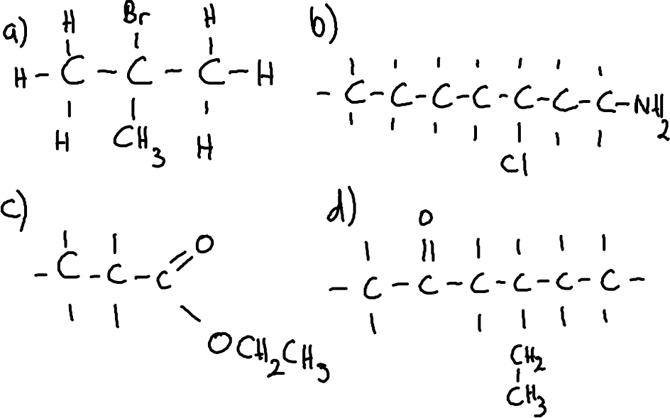

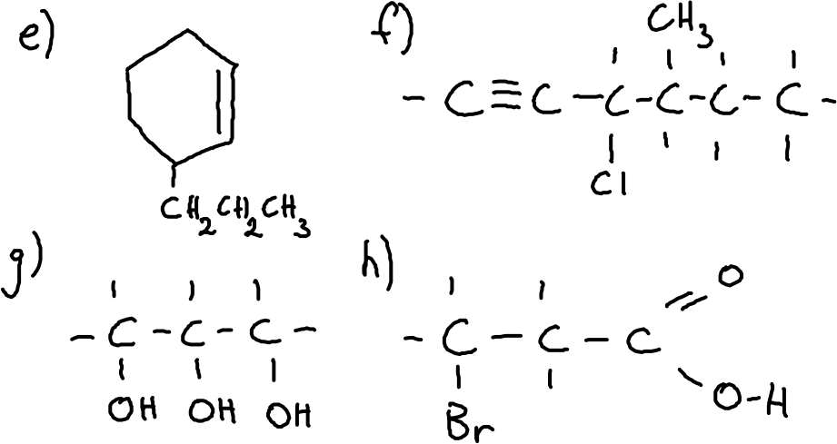

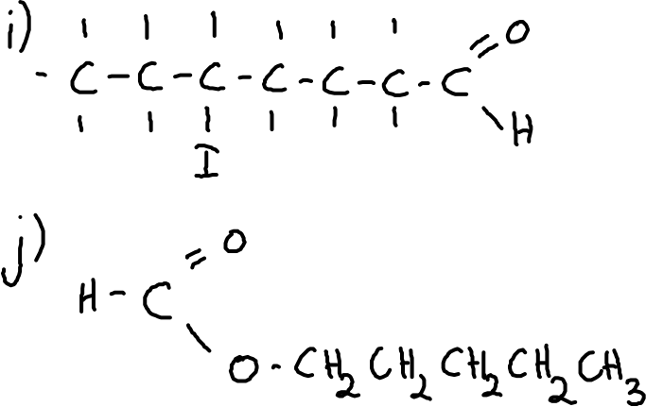

3. 1-hexene, cis-2-hexene, trans-2-hexene, cis-3-hexene, trans-3-hexene,

2-methyl-1-pentene, 3-methyl-1-pentene, 4-methyl-1-pentene,

2,3-methyl-1-butene, 3,3-methyl-1-butene, 3,3-methyl-2-butene, cyclohexane, methylcyclopentane, etc.

**ORGANIC REVISION TWO**

1. Draw structural formulas for each of the following.

a) 1, 1, 2-trifluorobutane

b) 2,2-dimethyl-3-pentanone

c) 3-chlorobutanoic acid

d) 3-chlorooctanal

e) ethyl heptanoate

f) 1-bromo-2-pentanol

2. Name each of the following compounds.

a) f)

 

b) g)

 

c) h)

 

d) i)

 

e) j)

 

3. Write balanced chemical equations for each of the following reactions.

a) Mixing excess bromine with ethyne

b) Adding methanoic acid to piece of sodium metal

c) Heating a mixture of methanol and pentanoic acid

d) Combustion of octyne

e) Incomplete combustion of heptene

f) Mixing chlorine with propene

g) Heating a mixture of ethanol and butanoic acid

h) Adding ethanoic acid to a piece of magnesium metal

i) Mixing bromine with ethane

4. There are several compounds that all have the structural formula of C8H18. Draw six of these compounds and name them.

5. a) Briefly describe how soap is made.

b) Write a general “word” equation for the making of soap

c) What is this process called?

6. a) Draw a molecule of the soap sodium stearate.

b) Write an equation showing the formation of the soap sodium stearate.

7. Pentane, pentene and pentanoic acid are all colourless liquids at room

temperature. Describe a series of chemical tests that could be carried out to distinguish between these three organic compounds. Remember to explain if there is no change as well as what is changing.

ANSWERS

1. 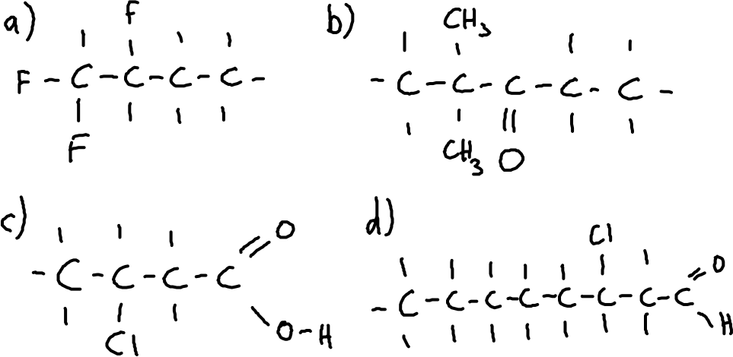

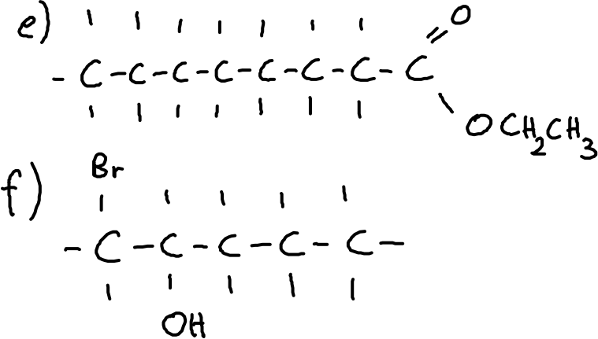

2. a) 3-methylcyclopentene

b) 3-pentanone

c) 3-bromobutanoic acid

d) 1,3-difluoro-2-butene

e) 2,2-dimethyl-1-butanol

f) propyl ethanoate

g) 1-amino-2-chlorobutane

h) diethyl ether

i) butanal

j) 3,4,5-triiodohept-1-yne

3. 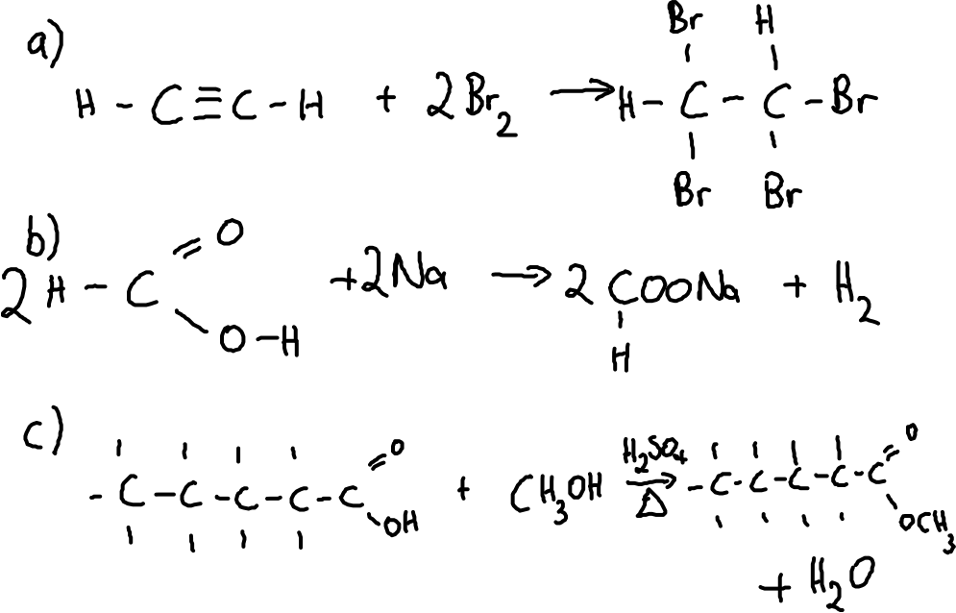

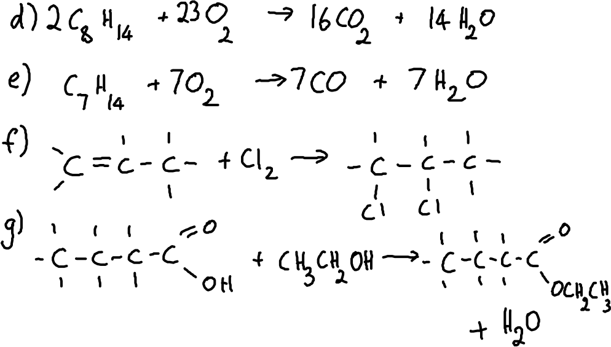

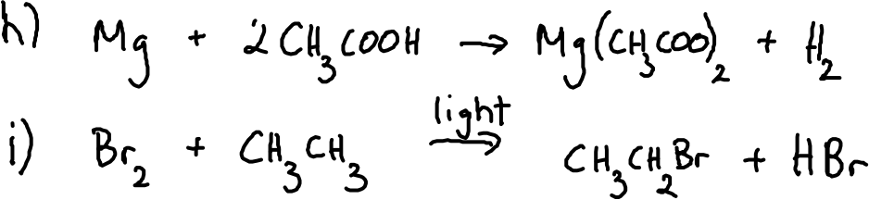

4. Octane

2-methylheptane, 3-methylheptane, 4-methylheptane

2,2-dimethylhexane, 2,3-dimethylhexane, 2,4-dimethylhexane,

2,5-dimethylhexane, 3,3-dimethylhexane, 3,4-dimethylhexane

3-ethylhexane

2,2,3-trimethylpentane, 2,2,4-trimethylpentane, 2,3,3-trimethylpentane,

2,3,4-trimethylpentane

3-ethyl-2-methylpentane, 3-ethyl-3-methylpentane

2,2,3,3-tetrmethylbutane

5. a) Heating a mixture of sodium hydroxide and an oil (triglyceride).

b) NaOH + triglyceride → glycerol + soap

c) Saponification

6. 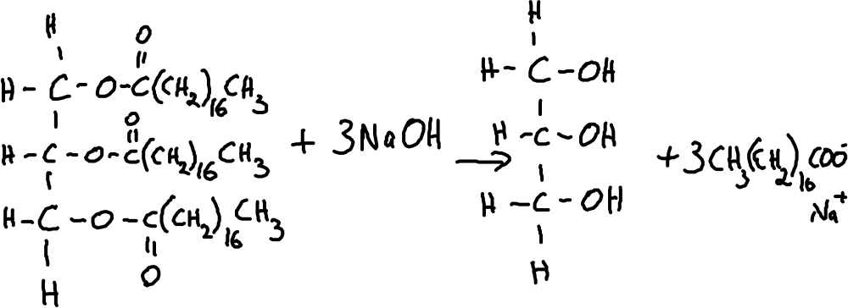

7. Add blue litmus to all 3 solutions. No reaction in pentane or pentene. Pentanoic acid will change it to red.

To pentane and pentene, add Br2 (aq). Pentene will decolourise the pentene immediately whereas the pentane will take much longer to react.